

**Tribhuvan University**

**Faculties of Humanities and Social Sciences**

**GYM SUBSCRIPTION MANAGEMENT SYSTEM**

**A PROJECT REPORT**

**Submitted to**

**Department of Computer Application**

**Danfe College**

**Sinamangal, Kathmandu**

***In partial fulfillment of the requirements for the Bachelors in Computer Application***

**Submitted by**

Sharmila Pyatha (6-2-920-27-2020)

Suman Mushyakhwo (6-2-920-32-2020)

October, 2023

**Under the Supervision of**

**Bijay Mishra**



**Tribhuvan University**

**Faculty of Humanities and Social Sciences**

**Danfe College**

**SUPERVISOR’S RECOMMENDATION**

Thereby recommend that this project prepared under my supervision by **Sharmila Pyatha** and **Suman Mushyakhwo** entitled “**GYM SUBSCRIPTION MANAGEMENT SYSTEM**” in partial fulfillment of the requirements for the degree of Bachelor of Computer Application is recommended for the final evaluation.

-------------------------

**SIGNATURE**

Mr. Bijay Mishra

**PROJECT SUPERVISOR**

BCA Department

Danfe College, Sinamangal, Kathmandu



**Tribhuvan University**

**Faculty of Humanities and Social Sciences**

**Danfe College**

**LETTER OF APPROVAL**

This is to certify that this project prepared by **Sharmila Pyatha** and **Suman Mushyakhwo** entitled “**GYM SUBSCRIPTION MANAGEMENT SYSTEM**” in partial fulfillment of the requirements for the degree of Bachelor in Computer Application has been evaluated. In our opinion it is satisfactory in the scope and quality as a project for the required degree.

|  |  |
| --- | --- |
| ………………………………  **Mr. Bijay Mishra**  Supervisor  BCA Department  Danfe College, Sinamangal  Kathmandu | ……………………………..  **Mr. Bijay Mishra**  Program Coordinator  BCA Department  Danfe College, Sinamangal  Kathmandu |
| …………………………………..  **Internal Examiner** | …………………………………  **External Examiner** |

# ABSTRACT

The Gym Subscription Management system is a web-based application and developed using spiral model that allows gym members to manage their subscriptions. The system provides users with the ability to sign up for gym memberships, view membership options and pricing. The system has two types of users: gym members and gym administrators. Gym members can sign up for memberships, view their membership details. Gym administrators can manage gym membership data, information regarding their exercise. The system uses CRUD operations to manage gym membership data. Users can create new membership records, update membership information, and delete memberships if necessary. The Gym Subscription system is designed to be user-friendly and easy to use. It provides users with a streamlined process for managing their gym memberships, making it a valuable tool for both gym members and administrators.

***Keywords: Gym Subscription Management, Web-based application, Membership options, CRUD, User-friendly.***

# ACKNOWLEDGEMENT

Apart from the efforts, I would like to thank **Mr. Bijay Misra** and **Deepak Thakur**, our project coordinator and lecturer, for his patience, support and open-mindedness. Without his encouragement and guidance this project would not have materialized. We feel motivated and encouraged every time we attend his meeting. We take this opportunity to express our gratitude to the people who have been instrumental in the successful Completion of this project. The guidance and support received from all the members who contributed and who are contributing to this project, was vital for the success of the project.

**TABLE OF CONTENTS**

ABSTRACT i

ACKNOWLEDGEMENT ii

LIST OF TABLES v

LIST OF FIGURES vi

LIST OF ABBREVIATIONS vii

CHAPTER 1: INTRODUCTION 1

1.1. Introduction 1

1.2. Problem statement 1

1.3. Objective 1

1.4. Scope and Limitation 2

1.5. Report Organization 2

CHAPTER 2: BACKGROUND STUDY AND LITERATURE REVIEW 3

2.1. Background Study 3

2.2. Literature Review 4

CHAPTER 3: SYSTEM ANALYSIS AND DESIGN 5

3.1. System Analysis 5

3.1.1. Requirement Analysis 5

3.1.2. Feasibility Analysis 7

3.1.3. Data Modeling(ER-Diagram) 8

3.1.4 Process Modeling 9

3.2. System Design 11

3.2.1. Architectural Design 11

3.2.2. Database Schema Design 12

3.2.3. Interface Design (UI Interface / Interface Structure Diagram) 13

3.2.4. Physical DFD 16

CHAPTER 4: IMPLEMENTATION AND TESTING 17

4.1. Implementation 17

4.1.1. Tools Used (CASE tool, Programming Languages, Data Platforms) 17

4.1.2. Implementation Details of Modules (Description of Procedures / functions) 18

4.2. Testing 20

4.2.1. Test Cases for Unit Testing 20

4.2.2. Test Case for System Testing 25

CHAPTER 5: CONCLUSION AND FUTURE RECOMMENDATIONS 28

5.1. Lesson Learnt / Outcome 28

5.2. Concussion 28

5.3. Future Recommendations 28

REFERENCES 29

# LIST OF TABLES

**Table 1 Test Case 0001 Sign Up** 20

**Table 2 Test Case 002 Sing Up Unsuccessful** 21

**Table 3 Test Case 003 Login** 23

**Table 4 Test Case 004 Add Category** 24

**Table 5 Test Case 005 System Test** 25

**Table 6 Test Case 006 System Test** 27

LIST OF FIGURES

**Fig 3. 1 Use Case Diagram of GSMS** 6

**Fig 3. 2 Gantt chart of GSMS** 7

**Fig 3. 3 ER Diagram of GSMS** 8

**Fig 3. 4 Context Level Diagram of GSMS** 9

**Fig 3. 5 DFD Level 1 of GSMS** 10

**Fig 3. 6 Architecture Design of GSMS** 11

**Fig 3. 7 Database Schema Design of GSMS** 12

**Fig 3. 8 Login Page UI of GSMS** 13

**Fig 3. 9 Signup Page UI of GSMS** 14

**Fig 3. 10 Dashboard Page UI of GSMS** 15

**Fig 3. 11 Physical DFD of GSMS** 16

LIST OF ABBREVIATIONS

**CSS** Cascade Style Sheet

**DFD** Data Flow Diagram

**ER** Entity Relationship

**FR** Functional Requirement

**GSMS** Gym Subscription Management System

**HTM**L Hypertext Markup Language

**MYSQL** My Structured Query Language

**PHP** Hypertext Preprocessor.

**UC** Use Case

**UI** User Interface

# 

# CHAPTER 1: INTRODUCTION

## 1.1. Introduction

A web-based Gym subscription system is a digital platform that offers individuals access to Gym-related activities, services, and resources through a subscription model. It allows users to conveniently access Gym options through a website.

With a web-based Gym subscription system, users can access a variety of Gym resources, such as workout routine plans and track membership expiry all through their web browser. These platforms may offer a range of Gym options to cater to different preferences. Users can choose and customize their Gym routine based on their body structure.

## 1.2. Problem statement

After analyzing many existing Gym subscription systems, we now have the obvious vision of the project to be developed. Before we start to build the application, we may have many challenges. We define our problem statement as:

The problem statement for a Gym subscription management system in Nepal is that there is a lack of efficient and modern systems for managing Gym subscriptions, which leads to several issues such as lack of proper planning and control, inefficient management of member data, difficulty in tracking payments and subscriptions, and poor communication between gym owners and their members. Most of the Gym centers use Excel and traditional paper-based systems to track the payment, subscription and member data which is a very bad experience in Nepal. This is a significant problem, especially for Gym centers and gyms that are looking to improve their services and attract more members. The traditional paper-based system is time-consuming, prone to errors, and does not offer the flexibility and convenience that modern-day member’s demand. And excel is very difficult to set formulas according to their needs. Therefore, there is a need for a digital solution that can help Gym centers and gyms manage their subscriptions effectively, automate payments and reminders, and improve overall member experience.

## 1.3. Objective

Some objective of Gym Subscription Management System are as follow:

* To track the membership expiry date.
* To provide a proper exercise routine according to their body structure.

## 1.4. Scope and Limitation

**1.4.1 Scope of System**

* Members can request for routine and view their routine through website
* Admin can manage data of members, categories and routines.
* Admin can keep track members subscription expiry date.
* Every Gym center can use this system to maintain data and other facilities.

**1.4.2 Limitation of Existing System**

The limitations of a Gym management system can depend on its specific design, implementation, and features. Here are some common limitations that may be associated with Gym management systems in the context of Nepal:

* Many gyms use Excel to keep track of their data, but this isn't the best way to do it.
* User interface is poorly designed.

## 1.5. Report Organization

**Chapter 1** includes introduction of the system Gym Subscription Management System with its problem of statement, objective and its scope and limitation.

**Chapter 2** includes the background study of Gym Subscription Management System and some literature review of other Gym Subscription Management System systems.

**Chapter 3** includes the functional and non-functional requirements along with feasibility

Analysis and architectural design of the Gym Subscription Management System.

**Chapter 4** includes the tools used in this system and the testing that is done.

**Chapter 5 i**ncludes about the outcome of this system as well as the future recommendations for the Gym Subscription Management System.

# CHAPTER 2: BACKGROUND STUDY AND LITERATURE REVIEW

## 2.1. Background Study

A Gym Subscription Management System is a software application or platform designed to assist individuals and organizations in managing various aspects of Gym and wellness. It provides tools and features that help with tracking, monitoring, and improving physical activity and membership expiry date. Understanding the Gym industry, its trends, and the challenges faced by Gym professionals and enthusiasts is crucial. Explore topics such as gym management. Given the sensitive nature of personal health and Gym data, it is important to consider security and privacy concerns when designing or using Gym management systems. Study topics such as data encryption, secure authentication, and compliance with data protection regulations. Analyze existing Gym management systems, both commercial and research-based. Examine case studies, academic papers, and industry reports to gain insights into successful implementations, user feedback, and areas of improvement.

Gym Subscription Management System has been prepared to eliminate the time required for the existing system. In the previous system, no records were secured because all of the paper work was there, and if the paper was misplaced, all of the records were lost, so to avoid all of these problems, this gym management system project was created. In a gym management system, it is necessary to have a system that can easily handle details while also providing user security. It also necessitates the use of software that stores information about employees and individuals. This is a very useful and beneficial system.

Over the years, the number of people joining gyms and health clubs has steadily increased in the fitness industry. Because of this expansion, more efficient and organized methods of managing memberships, payments, and member data were required. Fitness centers' membership offerings have expanded to include a variety of subscription plans, such as monthly, quarterly, and annual memberships, as well as day passes and trial periods. Managing these various membership types and billing cycles necessitated the use of specialized software. Technological advancements, particularly in the areas of cloud computing, mobile app development, and online payment processing, have simplified the creation and implementation of gym subscription management systems. Members began to expect more convenience and accessibility from their gyms as they became more tech-savvy and accustomed to digital experiences.

## 2.2. Literature Review

Muscle Power Gym in Godagama Srilanka, recognized the growing interest in health and fitness and created an IT solution to manage their growing membership. They gathered user requirements and created software to replace their manual system through iterative development. The software manages members, tracks attendance, manages fees, performs maintenance, and generates reports. It controls access with usernames and passwords and recommends workouts based on members' physical conditions. [1]

Gym management systems play a crucial role in facilitating the efficient operation and administration of Gym centers. These systems integrate various functionalities, such as membership management, providing routine to members, subscription tracking. This literature review aims to explore the existing research and literature surrounding Gym management systems, highlighting their benefits, challenges, and potential areas for improvement. Gym management systems enable members to easily register, view workouts plans and track subscription expiry resulting in a more engaging and convenient Gym journey. These systems automate tasks like membership enrollment, and routine scheduling, reducing administrative burdens and allowing staff to focus on delivering quality services. [2]

A gym subscription management system literature review would typically include an examination of existing research and literature on the topic. Gym subscription management systems are intended to help fitness centers streamline their administrative processes. Several studies have found similarities and functionalities in these systems. Membership registration, attendance tracking, class scheduling, and member communication are among them. According to research, implementing gym subscription management systems can result in a number of advantages for both gym owners and members. These advantages include higher member retention rates, better revenue management, increased member engagement through notifications and reminders, and lower administrative costs. The gym subscription management system landscape is expected to continue to evolve as technology advances. Emerging trends include the use of artificial intelligence (AI) for personalized fitness recommendations, improved data analytics for targeted marketing, and wearable devices for easy access and tracking. [3]

# CHAPTER 3: SYSTEM ANALYSIS AND DESIGN

## 3.1. System Analysis

The system analysis of the system is done by conducting requirement analysis, feasibility analysis, data modeling, and process modeling as follows:

## 3.1.1. Requirement Analysis

**Functional Requirement**

A Functional Requirement is an outline of the service that the Gym Subscription Management System must offer. Features the system must provide are refined into use case diagrams. To best capture the functional requirements of the system.

**Use Case**

The figure 3.1 is the use case diagram of the Gym Subscription Management System. There are two actors Member and Admin.

* The Admin is able to search members through name.
* The member is able to view the exercise routine.
* An Admin is able to login through their email and password
* A member is able to login through their email and password.
* A member is able to logout.
* A member is able to choose subscription categories.
* A member is able to request routine from the admin.
* An admin is able to manage categories, routine and member database.
* A member is able to see payment records from the beginning of his own.
* An admin is able to retrieve payment records of all members.
* A member is able to view their subscription expiry date.
* An admin is able to update members’ subscription date.
* An admin and members is able to update their profile info.

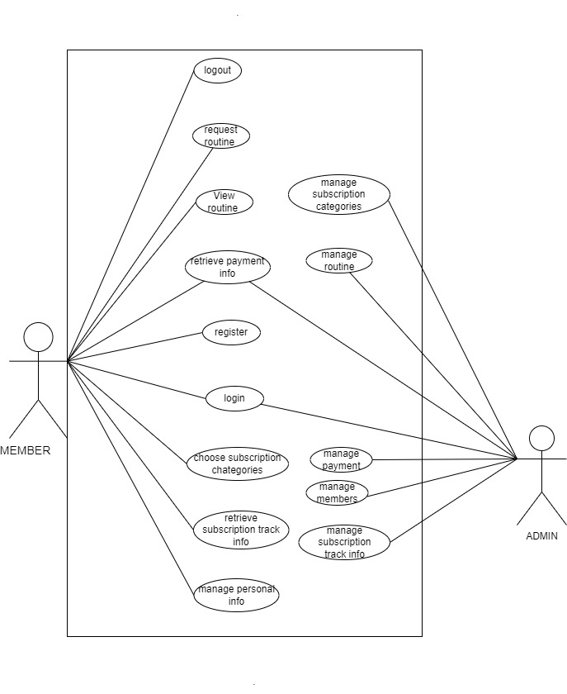

**Fig 3. 1 Use Case Diagram of GSMS**

**Non Functional Requirements**

* **Performance Requirement:** This system is designed for clean overall performance results. The performance of the Gym Subscription Management System will highly depend on the performance of the hardware and software components of the installed devices. Responses to view information shall take no longer than 5 seconds to appear on the screen.
* **Usability Requirement:** This system is very easy to use as it is written using basic html and PHP so that the user can interact with the system easily to do the needed work. And its security feature makes it very secure and reliable.
* **Environmental Requirement:** The system shall require a localhost server, database server, and a web browser to run successfully.
* **Compatibility Requirement:** The system is compatible across all platforms under the required environment.
* **Security Requirement:** Every user shall have a unique Session while logging into the system. The user password is in encrypted format in the database

## 3.1.2. Feasibility Analysis

The feasibility analysis of Gym Subscription Management System is done by measuring the following feasibilities, which are explained as follows:

* **Technical** :

The system can be implemented in various technologies presently available and in all technologies that will be implemented in the future.

* **Operational**:

This project is feasible to operate. The current mode of operation provides adequate throughput and response. So this project is entirely operational and can be operated on any platform.

* **Economic**:

No economic feasibility analysis has been conducted, but it can be done based on Function Point Analysis or the Kilo Line of Code method.

**Schedule Feasibility:**

Here is the Gantt chart showing the probability of the project being completed within its scheduled time limits by a planned due date.

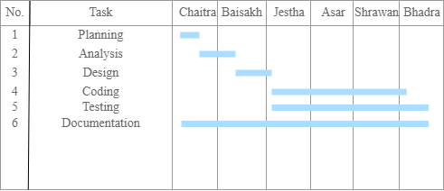

**Fig 3. 2 Gantt chart of GSMS**

## 3.1.3. Data Modeling(ER-Diagram)

Entity-Relationship Diagram of our proposed system (Gym Subscription Management System) is shown below. Here, Admin manages subscription category, members, routine, subscription track, and enrollment. Member choose categories, view routine and track their membership expiry. Each entity has its own primary key. For example admin has aid, member has mid, routine has rid.

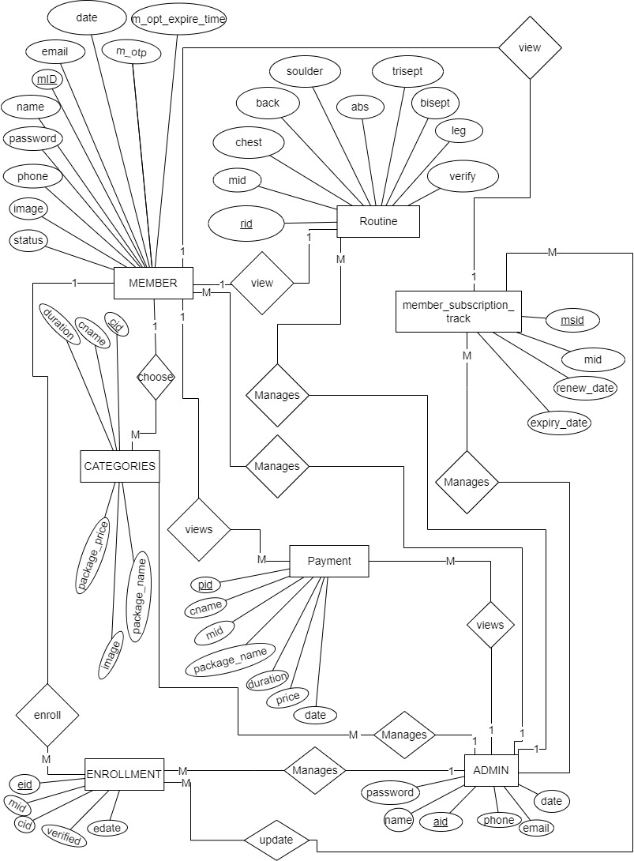

**Fig 3. 3 ER Diagram of GSMS**

## 3.1.4 Process Modeling

For process modeling of Gym Subscription Management System, context diagram and DFD level 1 are as follows:

**Context Level Diagram**

The figure 3.4 is also known as context level diagram. It's a basic overview of the whole system or process being designed. The above context level diagram shows the basic overview of "GSMS: Gym Subscription Management System". Here members shall register into the system by filling there basic information which is then stored in database. Then member shall be able to login with there credentials. Members shal be able to select a subscription category/plan and also obtain payment information and routine information. Admin shall manage members, categories, and payments, as well as retrieve member, category and payment information.

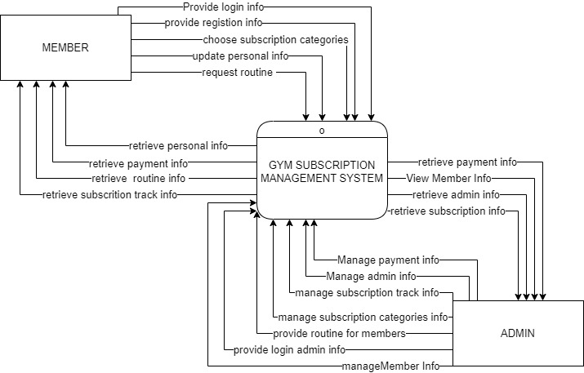

**Fig 3. 4 Context Level Diagram of GSMS**

## 

**DFD Level 1**

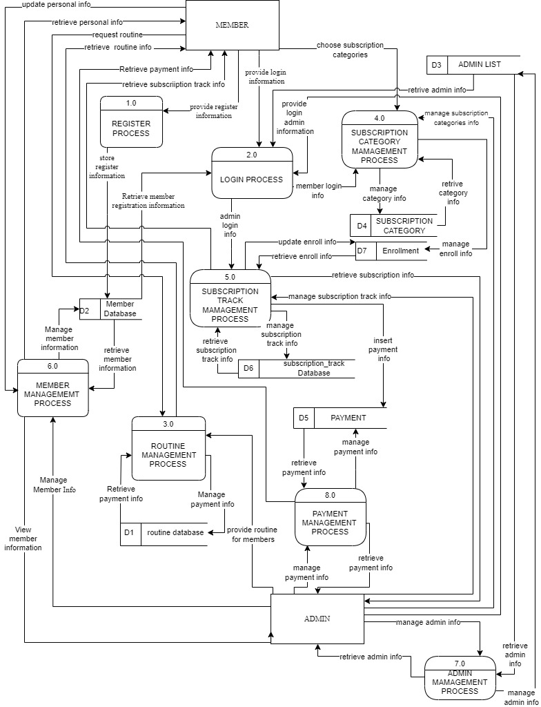

**Fig 3. 5 DFD Level 1 of GSMS**

The figure 3.5 provides a more detailed breakout of pieces of context level diagram. The above DFD provides the detail information of the context level diagram of " GSMS: Gym Subscription Management System ". The diagram shows that the member shall register into the system and register member should login into the system through login and register management. Member users’ details are managed through the member management process by admin.

## 3.2. System Design

The system design of Gym Subscription Management System consists of architectural design, database schema design, user interface design, and physical DFD are shown as follows:

## 3.2.1. Architectural Design

The figure 3.6 represents the architectural design of the GSMS: Gym Subscription Management System. There are two modules in the system. i.e., Member and Admin. Member shall register themselves into the system by filling up the necessary details and those details are saved in the member table of the database. Admin shall provide routine on the basis of member requests and manage categories. Member shall view the routine provided by the admin. Similarly, admin shall login to the system and manage the member data, payment information and enrollment.

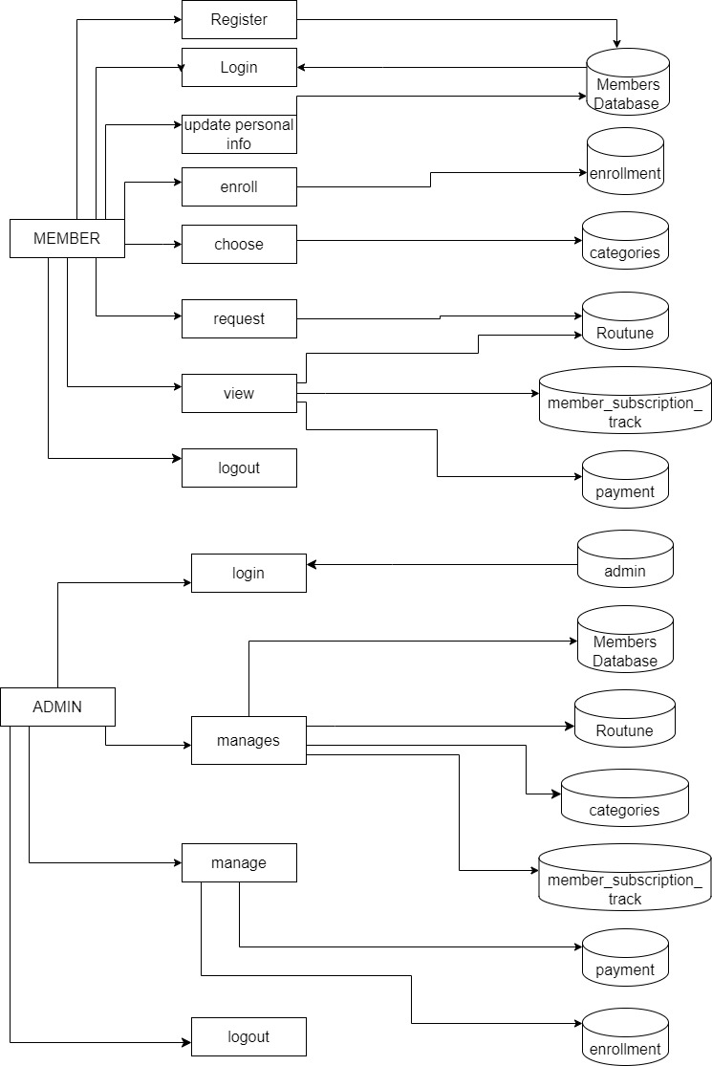

**Fig 3. 6 Architecture Design of GSMS**

## 3.2.2. Database Schema Design

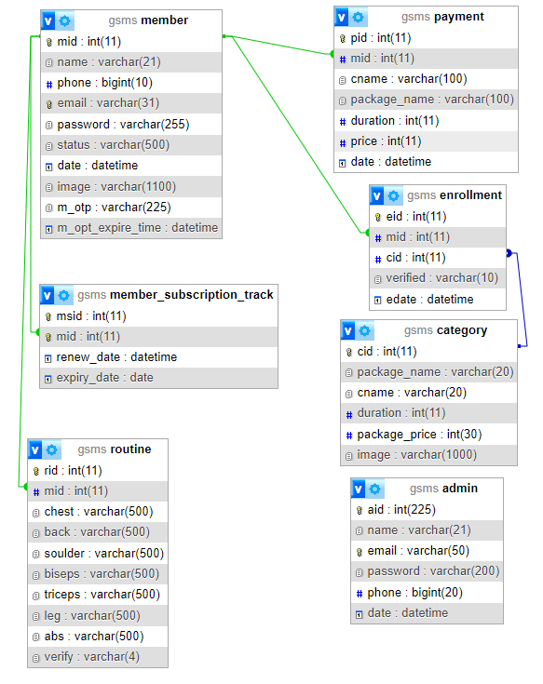

**Fig 3. 7 Database Schema Design of GSMS**

The figure 3.7 represents the database schema of the GSMS: Gym Subscription Management System showing all the relations (Member, Category, Enrollment, Routine, Member_Subscription_Track, payment and Admin) along with their respective attributes and inter-relationship between the relations.

## 3.2.3. Interface Design (UI Interface / Interface Structure Diagram)

The interface design for all the major pages of GSMS are shown as follow:

**Login Page UI**

The Login UI page of our proposed system (Gym Subscription Management System) is given below. By clicking on the login button, member shall log into the system by providing their correct email address and their password if they have an account. If they provide incorrect email or password the system won’t let them log into the system.

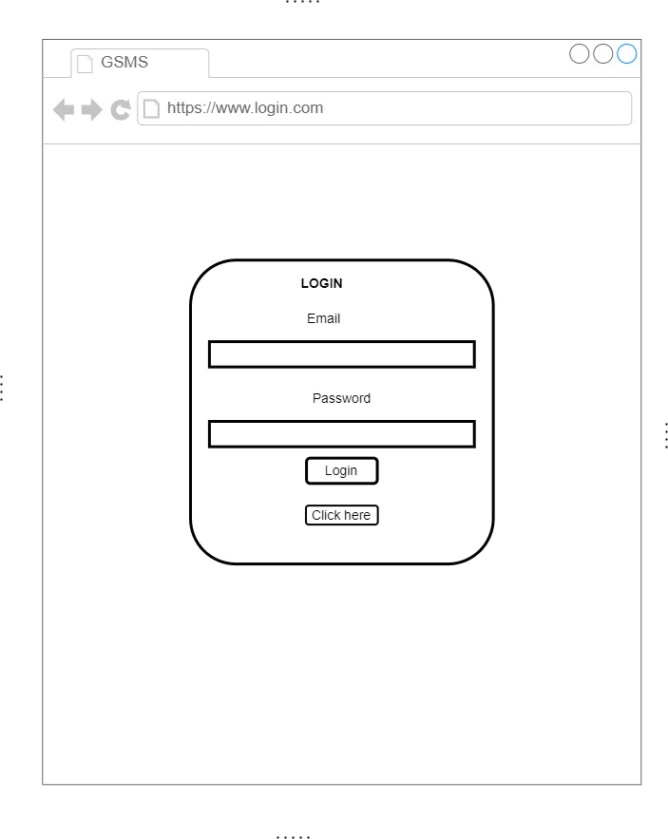

**Fig 3. 8 Login Page UI of GSMS**

**Signup Page UI**

The Signup UI page of our proposed system (Gym Subscription Management System) is given below. By clicking on the signup link member gets transferred to the signup page where they have to fill up all the necessary details required like full name, mobile number, email, password and confirm password. By clicking on the sign-up button, member information gets stored into the database of the system. Member have the option to login if they already have an account.

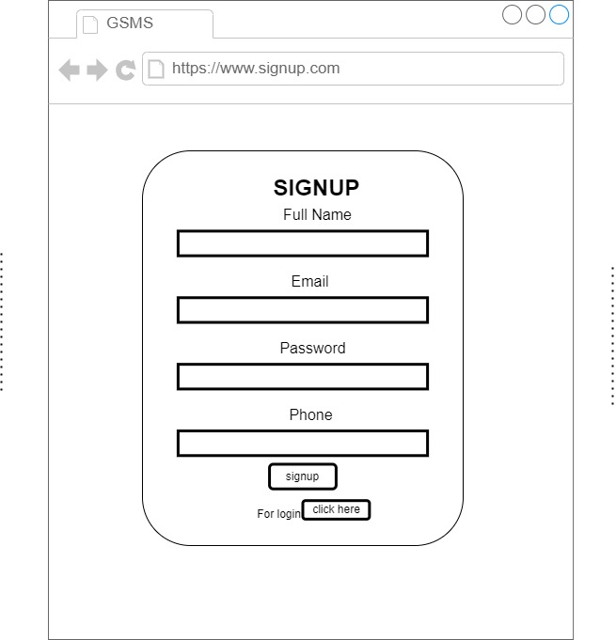

**Fig 3. 9 Signup Page UI of GSMS**

**Member Dashboard Page UI**

The figure 3.10 is the user interface for member dashboard page of GSMS: Gym Subscription Management System. It is the first page that opens on the screen when the user logs into the website via any browser. From there member can see category and enroll by clicking enroll button.

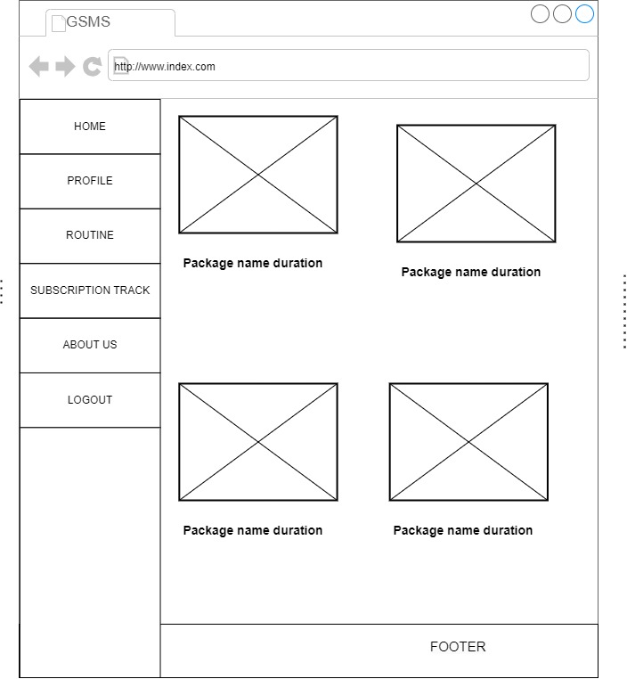

**Fig 3. 10 Dashboard Page UI of GSMS**

## 3.2.4. Physical DFD

The Physical DFD of our proposed system (Gym Subscription Management System) is given below. A Physical Data Flow Diagram (DFD) visually illustrates how data moves within a system at a detailed, physical level. A detailed physical data flow diagram can facilitate the development of the code needed to implement a data system.

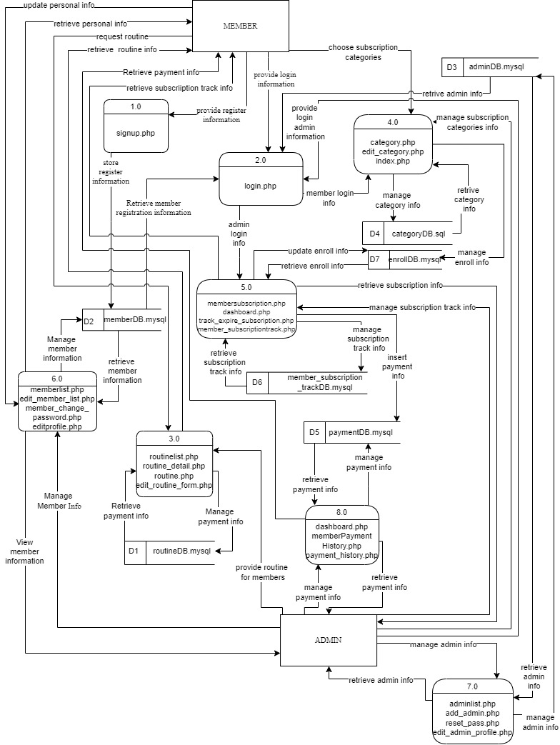

**Fig 3. 11 Physical DFD of GSMS**

# CHAPTER 4: IMPLEMENTATION AND TESTING

## 4.1. Implementation

The tools and techniques used to implement the system and the implementation details of various modules of Gym Subscription Management System are as follows:

## 4.1.1. Tools Used (CASE tool, Programming Languages, Data Platforms)

The tools used for the implementation of Gym Subscription Management are listed below:

**Draw.io**

Draw.io is an online diagram editor constructed around google drive. Using draw.io we have been capable of creating UML diagrams, entity relations diagrams, and plenty more. One of the benefits of draw.io is that it stores the information in google drive, consequently, there's no need for an extra third party.

**HTML CSS & JavaScript**

HTML, CSS, and JavaScript were used for the front-end development. HTML was used for the web page elements. CSS was used to provide its styling to the components. JavaScript was used for client-side validations and adding dynamic components to the Website.

**PHP**

PHP is a server-side scripting language that is embedded in HTML. It is included with some of the famous databases, which include MySQL, and its usage has helped us add, delete, and modify elements inside our database via PHP. Using PHP, we had been capable of limiting customers to get entry to a few pages of our website.

**MySQL**

MySQL is presently the most famous database management system software used for dealing with relational databases. It was used along with PHP scripts for developing our database structure. It became extensively utilized to carry out numerous activities like insertion, deletion, and update of the records saved in the database.

**Visual Studio Code**

Visual Studio Code is a lightweight but powerful source code editor which runs on computer systems and is available for Windows, macOS, and Linux.

## 

## 4.1.2. Implementation Details of Modules (Description of Procedures / functions)

The major function module of Gym Subscription Management System and their implementation is shown in the figure below:

1. **Signup module**

This module is used to register the new member into the system. Here the member has to fill up all the necessary details about themselves to get registered. These data gathered are first validated and then stored into the database using SQL query. After the registration the registered user shall log into the system by providing email and password which is identical to the email and password stored into the database.

$sql = "INSERT INTO member (name, email, phone, password) VALUES ('$name','$email', '$phone', '$password')";

1. **Login module**

This module checks whether or not a user has registered with the system. If a member has already registered, he or she can explore the system. If you are not a member, you will be unable to access the system.

$sql="select * from admin where email='$e' and password='$p'";

$sql="select * from member where email='$e' and password='$p'";

1. **Member module**

**For Edit Member Detail Module**

This module is used to update the existing member into the system. Here the member has to update all the necessary details. The data gathered are first validated and then updated into a database using SQL query.

If there is image sql will be:

$sql = "UPDATE member SET name='$n', phone='$ph', email='$e', image='$file_name' WHERE mid='$mid'";

If there is no image sql will be:

$sql = "UPDATE member SET name='$n', phone='$ph', email='$e' WHERE mid='$mid'";

**For Delete Member Detail Module**

This module is used to delete the data of existing member into the system.

$sql = "DELETE FROM member WHERE mid='$id'";

**For View all Members Detail**

This module is used to view the total member details which are existing into the system.

$sql = "select * from member";

1. **Category module**

**For Add Category Module**

This module is used to add the category into the system. Here the Admin has to fill up all necessary details about that category.

$sql = "INSERT INTO category (package_name,cname, duration, package_price, image) VALUES ('$pname','$cname', '$duration', '$price', '$file_name')";

**For Edit Category Module**

This module is used to edit the details of categories into the system.

$sql = "UPDATE category SET package_name = '$pname', cname = '$cname', duration = '$duration', package_price = '$price',image = '$file_name' WHERE cid = $cid;";

If image is not uploaded

$sql = "UPDATE category SET package_name = '$pname', cname = '$cname', duration = '$duration', package_price = '$price' WHERE cid = $cid;";

**For View all Category Detail**

This module is used to view the total category details which are existing into the system.

$sql = "select * from category";

1. **Payment module**

This module is used to insert, delete and view the data forum payment table of database.

**For delete:** $sql = "DELETE FROM payment WHERE pid='$pid'";

**For Insert:** INSERT INTO payment (mid, cname, package_name, duration, price, date)

VALUES ( '$mid', '$cname', '$package_name', '$duration', '$package_price', current_timestamp())";

**For View:** $sql = "SELECT member.mid, member.image, member.phone, member.name, payment.cname, payment.package_name, payment.pid, payment.duration, payment.price, payment.date

FROM member

INNER JOIN payment ON payment.mid = member.mid

ORDER BY payment.date DESC;";

## 4.2. Testing

The testing section is accomplished to validate the Gym Subscription Management System. The Gym Subscription Management System is examined to test if the final system can work in keeping with what we have been waiting for and is free from any programming and logical errors. It additionally makes sure whether or not all of the systems and requirements are met or not.

## 4.2.1. Test Cases for Unit Testing

Unit testing is a software program development method in which the smallest testable components of an application, known as units, are individually and independently scrutinized for correct operation. Below are the numerous tables for distinctive test cases:

**Table 1 Test Case 0001 Sign Up**

|  |  |  |  |  |
| --- | --- | --- | --- | --- |
| **S.N.** | **Test Case** | **Input** | **Expected Outcome** | **outcome** |
| 1 | Navigate to  sign up page | Path : http://localhost/ project/ signup.php | sign in page should open | As Expected i.e. Member is navigated to sign in page of system |
| 2 | Provide own details | Full name:  Email:  Password:  Confirm Password:  Phone no. | Credential can be entered | As expected |
| 3 | Click on signup button | clicked | User should sign up. | As expected. |
| **Post-conditions: Signup successful** | | | | |

**Table 2 Test Case 002 Sing Up Unsuccessful**

|  |  |  |  |  |
| --- | --- | --- | --- | --- |
| **S.N.** | **Test Case** | **Input** | **Expected Outcome** | **outcome** |
| 1 | Whenever the Name field contains a number or a symbol | Eg:  sum2an mushya@khwo | Display error message. | An Expected Error message is displayed. |
| 2 | If the name contains more than 20 alphabets | Eg:  suasdwawdaman mushyakhwo | Display error message. | As expected,  Error message is displayed. |
| 3 | if the phone number is less than or more than ten numbers long and contains any alphabets | Eg:  9862123456d12 | Display error message. | An Expected Error message is displayed. |
| 4 | if an invalid email address is entered | Eg:  Sumahyakhwogmailcom | Display Error message:  Output. | An Expected Error message is displayed. |
| 5 | if the email address entered is already registered |  | Display error message. | An Expected Error message is displayed. |
| 6 | if the password length is less or more than 10 characters | Eg: sumaasdadsn@1234 | Display Error message:  Output. | An Expected Error message is displayed. |
| 7 | if the password and confirmation password do not match |  | Display error message. | An Expected Error message is displayed. |
| **Post-condition :Sign Up Failed** | | | | |

**Table 3 Test Case 003 Login**

|  |  |  |  |  |
| --- | --- | --- | --- | --- |
| **Pre-conditions: The member has a valid email and password.** | | | | |
| **Dependencies: sign-up module** | | | | |
| **S.N.** | **Test Case** | **Input** | **Expected Outcome** | **outcome** |
| **1** | Navigate to login page | Path: http://localhost/project/login.php | Login page should open | As Expected i.e. Member is navigated to Login page of system |
| **2** | Correct email and  password | User must login successfully | User logged  into the system | As Expected i.e. User was able  to access the services provided  by the system |
| **3** | Incorrect email but correct password | User must not login | User was not  logged into the  system | User was not able to access the  services provided by the  system |
| **4** | Correct email but  incorrect password | User must not login | User was not  logged into the  system | User was not able to access the  services provided by the  system |
| **Post-conditions: Member is validated with database and successfully login into GSMS**  **The account session details are logged into the database.** | | | | |

**Table 4 Test Case 004 Add Category**

|  |  |  |  |  |  |  |
| --- | --- | --- | --- | --- | --- | --- |
| **Pre-conditions: Admin is login into Gym Subscription Management System** | | | | | | |
| **Dependencies: login module** | | | | | | |
| **S.N.** | **Test Case** | **Input** | **Expected Outcome** | **Output** |
| **1** | Navigate to category page | Path: http://localhost/project/admin/category.php | category page should open | As expected i.e. admin is navigated to category page of system |
| **2** | Click Add Category Button | Button click | Add category Form page should open | As expected i.e. admin is navigated to add category page of system |
| **3** | Provide all required information | Package name=  category name = gym(default)  price=  image= | Credential can be entered | As expected if all textboxes are filled and image validation is successful then it is accepted otherwise we will show an error. Error message. | |
| **4** | Data insertion | Click on the add  category | Admin should be able to add a category package into the system | As Expected i.e.  Admin can add the question to the system |
| **Post-conditions**  **The category is successfully inserted into the database.** | | | | | | |

## 4.2.2. Test Case for System Testing

System Testing is a form of software testing that is executed on a complete integrated system to assess the compliance of the system with the corresponding requirements.

**Table 5 Test Case 005 System Test**

|  |  |  |  |  |
| --- | --- | --- | --- | --- |
| **Pre-conditions: Admin is login into Gym Subscription Management System** | | | | |
| **SN** | **Test case** | **Input** | **Expected outcome** | **Output** |
| **1** | Check with admin login | email:admin[@gmail.com](mailto:sumanmushyakhwo@gmail.com)  password:admin@1234 | Successful login | Open dashboard |
| **2** | Check with delete and edit member from admin site | Click delete and edit button | Must be edited or deleted | Edit and delete messages should be displayed successfully. |
| **3** | Check with add categories | If required fields are filled. Then click the add category. | Successful entry of new category | Inserted data into the category table. |
| **4** | Check with delete and edit  Subscription categories | Click edit or delete button | Must be edited or deleted | Edit and delete messages should be displayed successfully. |
| **5** | Check with update or ignore requested routine by admin | Click update and ignore button | Must be updated or ignored. | Update message should be displayed successfully. |
| **6** | Check member enrollment with verified, Reject and by admin | Click verified and  Reject | Must be verified and rejected | Verified and message should be displayed successfully. |
| **7** | Check with logout | Click logout button | Successfully logout | Redirect to login |

**Table 6 Test Case 006 System Test**

|  |  |  |  |  |
| --- | --- | --- | --- | --- |
| **Pre-conditions: Member is login into Gym Subscription Management System** | | | | |
| **SN** | **Test case** | **Input** | **Expected outcome** | **Output** |
| **1** | Check with member login | Email: [sumanmushyakhwo@gmail.com](mailto:sumanmushyakhwo@gmail.com)  Password: suman@1234 | Successfully login | Open member index page |
| **2** | Check edit member profile button | Click update button | Must be edited successfully | Update into member database |
| **3** | Check request routine button | Click request button | Successfully routine is requested | Requests must be shown in the admin Routine page for update. |
| **4** | Check enrollment | Click on enroll button | Expiry date should be increased according to the packaged enrolled | Update expiry date according to category package |
| **5** | Check with logout | Click logout button | Successfully logout | Redirect to login |

# CHAPTER 5: CONCLUSION AND FUTURE RECOMMENDATIONS

## 5.1. Lesson Learnt / Outcome

With the growth and development of the project, we also grew our knowledge little by little. We have learned lots of problem-solving skills and learnt things like teamwork, finding the solution on our own, proper use of guidelines, communication and writing skills and management of the team. This project didn’t only help in our academic development but also widened our horizon of curiosity. We have found ourselves more eager to learn about new languages and designing techniques while developing this project.

## 5.2. Concussion

The Gym Subscription Management System is a very important tool for gym managers and members alike. It makes the gym better for members and helps things run smoothly. This technology helps gym operators to track memberships and communicate with them more efficiently. It aids in resource allocation, employee management, and revenue growth. It also provides useful insights about member behavior and preferences, allowing for data-driven decision-making. The Gym Subscription Management System provides members with simplicity and transparency. They can simply join up for memberships, make payments, and check their account information via online. This improves their overall experience and fosters long-term gym engagement.

## 5.3. Future Recommendations

The following section describes the work that will be implemented with future software releases.

* We can add video tutorials and exercise guides.
* We may add schedule members for morning, midday, and evening workouts according on their needs.
* We can add image galleries and blogs to attract new members to the gym.
* Allow members to perform online payment as well.
* Generation of billing systems.
* Enhance the member interface by incorporating more interactive features

# REFERENCES

|  |  |
| --- | --- |
| [1] | GAMAGE, "Web based Gym Management System," [Online]. Available: https://dl.ucsc.cmb.ac.lk/jspui/handle/123456789/3899. [Accessed 2023]. |
| [2] | A. KUMAR, "php gurukul," [Online]. Available: https://phpgurukul.com/gym-management-system-using-php-and-mysql/. [Accessed 10 9 2023]. |
| [3] | N. Bajracharya, "Gym Management System in PHP MySQL," [Online]. Available: https://codeastro.com/gym-management-system-in-php-mysql-with-source-code/. [Accessed 20 May 2023]. |
| [4] | A. KUMAR, "php gurukul," [Online]. Available: https://phpgurukul.com/how-to-compare-two-dates-in-php/. |
| [5] | R. S. Saud and M. Giri, Software Engineering, KEC, 2077. |
| [6] | S. B. Saud and I. Chaudhary, DataBase Management System, KEC, 2023. |
| [7] | draw.io, "Flowchart Maker & Online Diagram Software," app.diagrams.net, [Online]. Available: https://app.diagrams.net/. |

​  
​  
​  
​

**APPENDICES**

1. **Member Home Page**



1. **Member Login page**



1. **Member Signup page**



1. **Admin Login Page**



1. **Admin dashboard**



1. **Member Management Page**

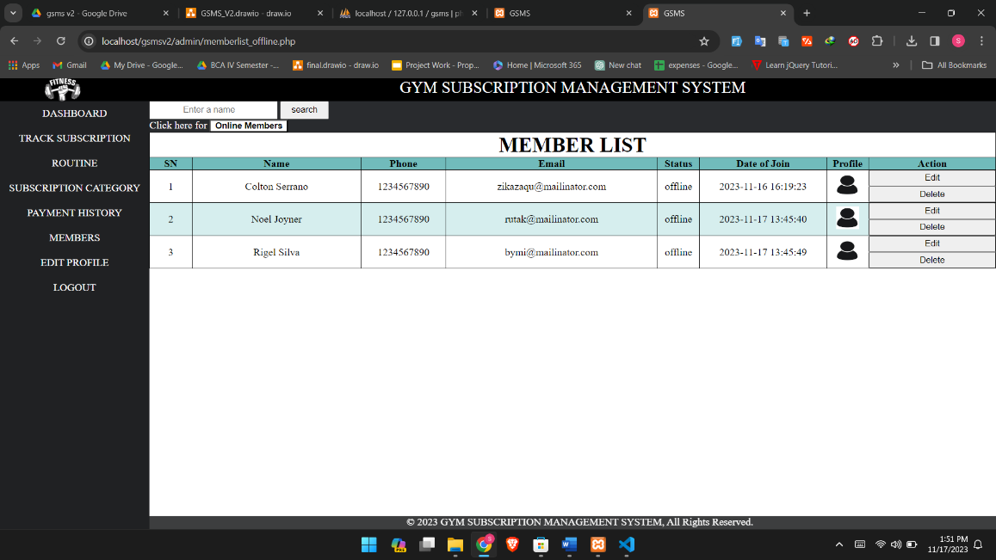

1. **Routine Management Page**



1. **Routine list**



1. **Category Management Page**



1. **Subscription track**

